Blue Book on

Smart Weighing Machine

Submitted in partial fulfillment for the award of the degree
of
BACHELOR OF ENGINEERING
In
COMPUTER ENGINEERING
By

Bhavesh Jadav
Kaushal Mania
Akash Pujari

Under the Guidance of
Mr. Anand Khandare

Designation
<Times New Roman 12 pt>



University of Mumbai
Department of Computer Engineering (2016-17)


TEGTEG

CERTIFICATE

This is to certify that Mr. Bhavesh Jadav, Mr. Kaushal Mania, Mr. Akash Pujari are bona fide students of Thakur College of Engineering and Technology, Mumbai. They have satisfactorily completed the requirements of the PROJECT-I as prescribed by University of Mumbai while working on “Smart Weighing Machine”.

Mr. Anand Khandare  (Guide) | Dr. Rekha Sharma  ( HOD CMPN) | Dr. B. K. Mishra  (Principal)
Internal Examiner: External Examiner:

Signature with Date: Signature with Date:

Name: Name:

PLACE: Mumbai
Thakur College of Engineering and Technology
Kandivali (E), Mumbai-400101.

DATE:

Acknowledgement

We sincerely thank our guide Mr. Anand Khandare for his guidance and constant support and also for the stick to our backs. We also thank the project coordinators for arranging the necessary facilities to carry out the project work.

We thank the HOD, Dr. Rekha Sharma, Dean Academic Dr. R.R Sedamkar, the Principal, Dr. B. K. Mishra and the college management for their support.

(Signature)
(Bhavesh Jadav (BE-CMPN-A-31))

(Signature)
(Kaushal Mania (BE-CMPN-A-44))

(Signature)
(Akash Pujari (BE-CMPN-A-67))

ABSTRACT

Now a day’s farmer uses pen and paper or simple spread sheet to keep track of their farm produce which is prone to human errors. Objective of this project is to build a Weighing Machine which will automatically log the weight of the crop and its other information directly into database with push of one button. With this project, we are also plan to increase transparency between customer and farmers. Customer will know about farm produce in instant instead of waiting days. This can also help to reduce hoarding caused by middle man or retailers. If the middle man tries to hide the stock to increase market price in that case customer will have idea about total farm produced at that time. This concept is not limited to only farmers but this can be applied to any fields like Dairy Products, Fish Markets etc. This weighing machine will be very similar to other weighing machine and will have all the functionality that standard weighing machine has so it will be easier to use as standard weighing machine. This project will use open source technology such as Raspberry pi, Arduino for hardware, ASP.NET Core for web interface etc. All the data which is stored in database will be displayed using web interface. Each user will have their own account protected by password. In this web interface, user will be able to do all the basic task such as adding new item, removing item, adding new location, change password or email etc. Weighing machine will use LCD to display data and will also have keypad to take input from user. It is also important to find weight of which object is being taken to completely automate the entire process. Instead of entering which object is placed on weighing machine manually we can use RFID tags or QR code or Image processing to automatically identify the object so user don’t have to tell the machine about the object.

INDEX

Chapter No. | Topic |  | Pg. No.
 | - List of figures |  | I
 | - List of Tables |  | II
Chapter 1 | Introduction
 | 1.1 | Introduction
 | 1.2 | Motivation
 | 1.3 | Problem Definition
 | 1.4 | Objectives of the Project
 | 1.5 | Scope of the Project
 | 1.6 | Applications of the Project
 | 1.7 | Project Impact Analysis
 | 1.8 | Expected Outcome of the Project
 | 1.9 | Organization of the Project Report
Chapter 2 | Literature Review and Proposed Work
 | 2.1 | Literature Survey
 | 2.2 | Proposed Work
Chapter 3 | Requirement Gathering, Analysis and Planning
 | 3.1 | Requirement Specification
 | 3.2 | Feasibility Study
 | 3.3  3.4  3.5 | Methodology  Technology  Time Line Chart
Chapter 4 | Design Phase
 | 4.1  4.2  4.3  4.4 | Data Flow Diagram/ Physical layout  UML Diagrams/ Block Diagram  User Interface Design(Snapshots)  Database Design (if applicable)
Chapter 5 | Conclusion  References
Appendix A
- Abbreviation and symbols
Appendix B
- Definitions

List of Figures
<Times New Roman 16pt Bold>

Figure 1: …………………………….
Figure 2: …………………………….
Figure 3: …………………………….
Figure 4: …………………………….
Figure 5: …………………………….
Figure 6: …………………………….
Figure 7: ……………………………….
Figure 8: ……………………………….
Figure 9: ……………………………….
Figure 10: ………………………………
Figure 11: …………………………….
<Times New Roman 12 pt>

List of Tables

Table I: …………………………….
Table II: ……………………………..
Table III : ……………………………..
Table IV: ……………………………..
Table V: ……………………………..
Table VI: ……………………………..
Table VII: ……………………………….
Table VIII: ……………………………….
Table IX: ………………………………..
Table X: ………………………………

Chapter 1

Introduction

  - Introduction
Through this project we are planning to automate the process of cataloging information about farm produce by introducing a weighing machine which is very similar to other standard weighing machine and it will handle all the cataloging process. All the data collected by weighing machine will be stored in online database. User can access all this data through web interface. This will also help to increase transparency between farmers and customer.

  - Motivation
Usually farmer used book and pen to catalog information about their farm produce or some uses excel sheet or google spread sheet. All the information is cataloged manually by person and this method is prone to human errors. If there is second person is hired to do cataloging process than he or she may perform some malicious activity and might enter wrong data. It will be easier if there is way to do all this thing automatically without human intervention. So, there needed a way to perform all this task automatically. Since weighing machine is crucial part in farming, it will be easier to integrate automation process in weighing machine. Through weighing machine all the data will be recorded and stored in database.

  - Problem Definition
We want to make cataloging process of data in fields such as farming where weighing of product is crucial part by providing automated solution which will handle all the cataloging process.
Current methods of cataloging process are prone to human error and in the field of farming once the crop is harvested the end customer will only know it reaches the market and that usually takes long time. Through this automated process end customer will have information about crop harvest faster than before and this also reduces the risk of hoarding since end customer will have information about crop harvest before it reaches the market.

  - Objectives of Project
- Decrease human effort in cataloging process of farm produce, dairy products etc.
- To build cost effective weighing machine.
- To build easy to understand web interface.
- To increase transparency between end customer and farmer.

  - Scope of the project
Initially website is being developed including database, user interface, web API, user management. In next phase weighing machine, will be built using open source hardware. After both weighing machine and website are completed they will be communicating using web API to reduce data usage. At the final stage, rigorous testing will be carried out to make sure that final product in robust.

  - Application of project
- In our weighing machine the information need not be entered manually. The machine is connected to a database with will be storing all the information and this information can be easily retrieved from a website.
- The information stored in the website is analyzed and represented in such a way that it is beneficiary for the end user.
- Only registered users can access the information from the website.
- Our machine will provide a robust way to catalogue information.
- Our machine can be used in different industries like Dairy Products, Farming and Fish Market etc.
- To use this machine user, need not have technical knowledge about the machine.
For example:
Consider a farmer who needs to weigh his produces and catalogue that information Our machine will weigh the produce and system will instantaneously update the details of the farm produce in the database which will then be reflected in the web portal. Farmers can later view the statistics of his/her produce on the website which is organized in such a way that it will be helpful in future.

  - Projects Impact Analysis
One of the reason to build this project is to reduce hoarding in food supply. By law traders are allowed to hold a certain quantity of essential food grains such as rice, wheat and pulses. A

  - Expected Outcome
Fully functional weighing machine which can be connected to the internet and will have all the similar functionality of standard weighing machine. A fully functional website which will display all the data.

  - Organization of the Project report
----------------------------------------------------------------------------------------------------------------------------------------------------------------------------------------------------------------------------------------------------------.

Chapter 2
Proposed Work and Literature Review
2.1 Literature Survey
Authors Name | Title | Conclusion | Summary | Gap Identification
Banyat Nimsiriwangso, Sart Kummool, Amphawan Julsereewong, and Prapart Ukakimaparn | Automatic Weighing Machine for Improving Competitiveness of  Thai SMEs in Seafood Cold Storage Business[1] | A design and implementation of automatic weighing  machine for fresh fish products has been presented. | Weighting operations can be controlled accurately. In  addition, the proposed weighing machine requires small  investment of 750,000 Bath with a payback period of 1.14  years. | This machine is solely created to handle need of fish market
Lan Bai, Cunyan Zhang, Jian Hu | An Improved DEA Approach and Its Application on Fresh Farm Produce Logistics  Performance Measurement [2] | The input-output two-way evaluation index system  integrated FFAL management and DEA characteristic  strengthen the rationality and feasibility of evaluation  program. | To evaluate the  FFPL performance, this paper explores the performance  evaluation status and data envelopment analysis (DEA)  method principle, takes 10 samples. | This method only deals with the logistics related issues with farm  produce.
Table I: Literature review

2.2 Proposed Work
There are weighing machine exists which are connected to the internet but they are used to maintain information about human body weight, fat etc. [3]
Chapter 3
Requirement Gathering, Analysis and Planning
3.1 Requirement Specification
Software Requirement:
- ASP.NET Core 1.0.1 For backend
- Entity Framework Core for database connectivity and migrations
- AdminLTE bootstrap template for front end of website
- Visual Studio 2015 IDE for coding
- Solidworks 2015 for CAD modelling
- POSTMAN for API testing
- SQL Server Management Studio 2014 for database management
- Microsoft Azure for hosting purpose
Hardware Requirement:
Name | Detail
Raspberry Pi | Main heart of the weighing machine which will handle all the communication
Load cell | It will be used to measure weight of the object
GLCD | To display information
SD card | For raspberry pi
Keypad | To take input from the user
DC-DC convertor | For power supply
Arduino | For extra IO pins
ADC amplifier | For load cell
12v power supply | To supply power to whole system
USB camera | For scanning QR code
Wires | For connections
Acrylic | Parts for making body and other parts of weighing machine
Miscellaneous hardware | Screws, washers, glue, screw driver etc.
Task Breakout:
Task 1 | Requirement gathering
Task 2 | Problem Analysis
Task 3 | Identifying Components
Task 4 | Gathering information about parts  and purchasing the parts
Task 5 | Designing weighing machine
Task 6 | Designing website
Task 7 | Building website
Task 8 | Connecting hardware and coding on weighing machine
Task 9 | Fabricating body of weighing machine
Task 10 | Communication between weighing machine and server
Task 11 | Testing
Task 12 | Final deployment

3.2 Feasibility Study
All the resources are available to complete this project. Most of the technology used in this project is open source hence there also will be community support. The weighing machine in this project is easier to build and similar to another standard weighing machine. The cost of this weighing machine will be also similar to another weighing machine.

3.3 Methodology
In this project Software Development Life Cycle methodology, will be used. SDLC emphasize on combining two or more project management methodologies for the best outcome. Using Adaptive Project Framework for to adjust requirement, using Feature Driven Development for managing features in product and using Rapid Application development to produce faster result and reuse the component to increase efficiency.

3.4 Technology
- Load cell will be used to measure the weight of the entity. It uses Wheatstone bridge. It has one register on top and one resistor at the bottom. When weight is applied on the load cell top resistor will stretch and bottom resistor will shrink causing voltage difference between two points. We can use this change in the voltage to determine the weight of the object. The voltage difference produce is usually very small hence we need amplifier to amplify the signal.
- Raspberry pi is the main heart of this machine. It will handle all the calculation to measure the weight, interaction between keypad and LCD, storing data and transferring it to server.
- Website backend will be made using ASP.NET Core which is developed by Microsoft. Along with ASP.NET, MVC6 will be used to separate logical concern, database concern and business logic. The front end of the website will be made using AdminLTE template which is an open source Bootstrap template.
- To store data Microsoft SQL Server will be used.
- Data first will be stored locally in raspberry then it will be transferred to server. This is to prevent data loss means if server is not working then data will be safe in raspberry pi local database and if the machine is not working then data will be safe in server database.
- For LCD, we are using 128x64 Graphical LCD.
- For keypad, we are using 4x4 keypad with tactical feedback. Using 4x4 keypad we will get more number of keys which can include full number pad and other keys.
3.5 Time Line Chart
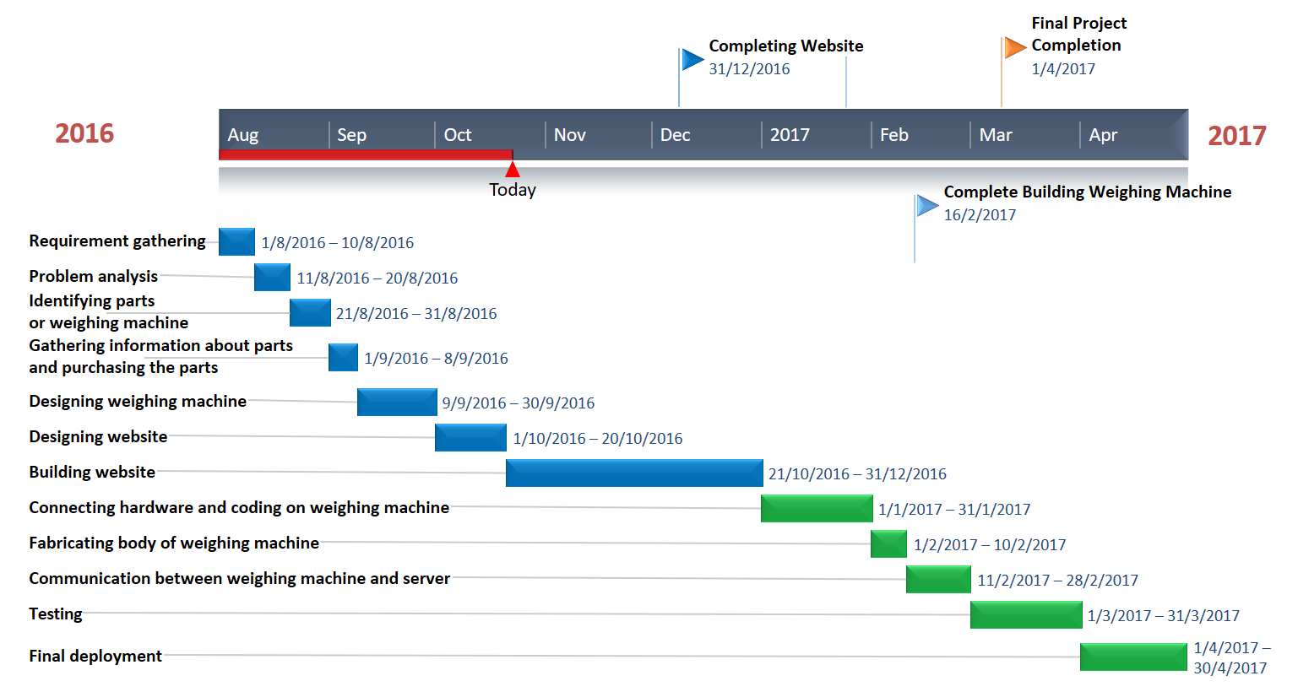
Figure 1: Timeline chart

Chapter 4
Design phase
4.1 Data Flow Diagram/ Physical layout
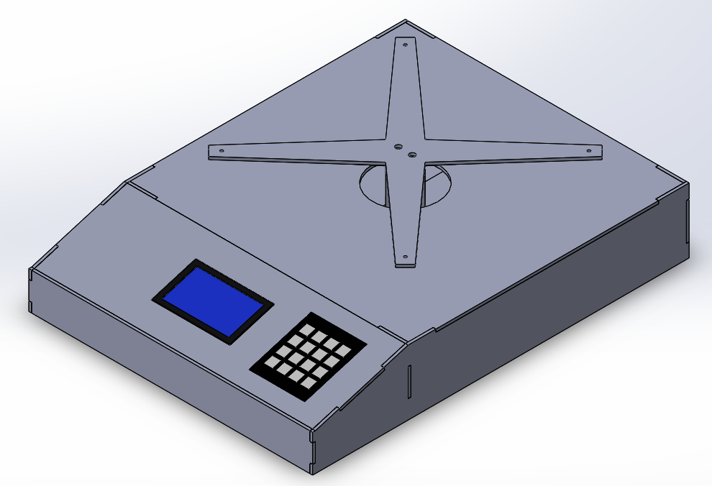
Figure 2: CAD model of weighing machine

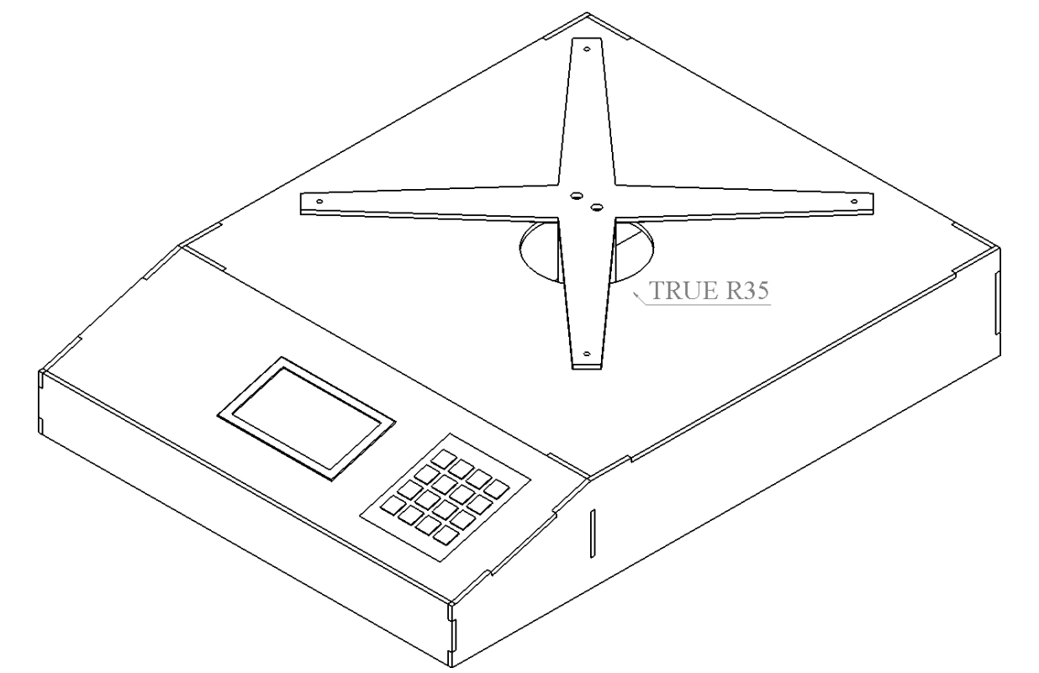
Figure 3: Isometric view of weighing machine
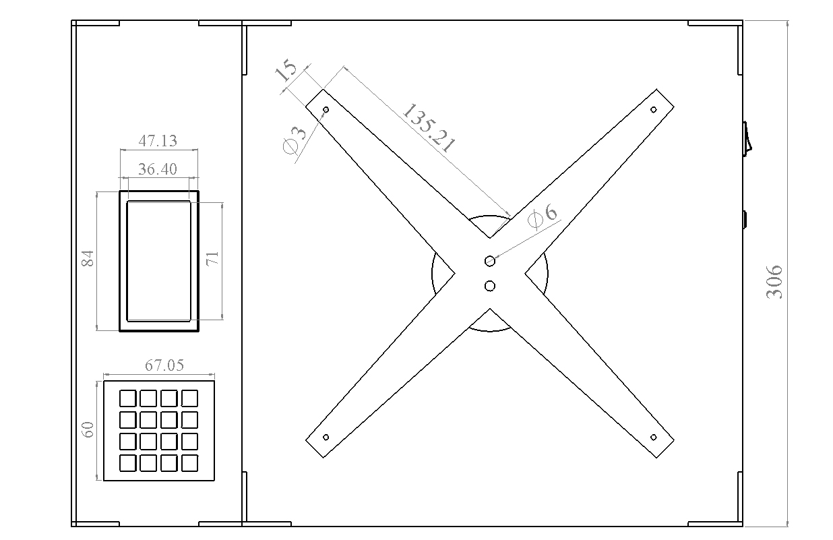
Figure 4: Top view of weighing machine

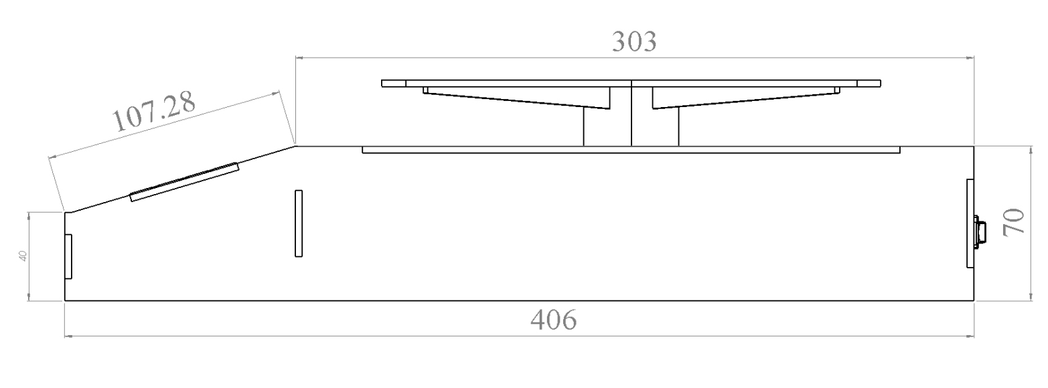
Figure 5: Side view of weighing machine

There will be weighing platform on top of the cross. Weighing platform can be built according to the needs. For example, flat weighing platform, circular weighing platform, bawl shape weighing platform etc.

4.2 UML Diagrams/ Block Diagram

4.3 User Interface Design (Snapshots)
-------------------------------------------------------------------------------------------------------------------------------------------------------------------------------------------------------------------------------------------------------------------------------------------------------------------------------------------------------------------------------------------------------------------------------------.
4.4 Database Design (if applicable)
-----------------------------------------------------------------------------------------------------------------------------------------------------------------------------------------------------------------------------------------------------------------------------------------------------------------------------------------------------------------------------------------------------------------------------------------.

Chapter 5
Conclusions
------------------------------------------------------------------------------------------------------------------------------------------------------------------------------------------------------------------------------------------------------------------------------------------------------------------------------------------------------------------------------------------------------------------------------------------------------------------------------------------------------------------------------------------------------------------------------------------------------------------------------------------------------------------------
---------------------------------------.

References< Times New Roman 16pt bold>
Student must use IEEE format for writing references. Some examples are given below

The listing of references should be typed 2 spaces below the heading “REFERENCES” in order of its appearance in thesis in single spacing left – justified with Times New Roman font type. The name of the author/authors should be immediately followed by the year and other details. References should be cited in the text at appropriate places as [n] in serial order as they appear in the text. Every reference in the list must be cited at least once in the report.
A typical illustrative list given below relates to the citation example quoted above.
For a paper in a Proceedings/Transactions/Journal
- J Woods and S O Neil,”Subband coding of Images”, IEEE Trans on Acoustic speech signal processing, Vol 1, No.3, pp. 1278- 1288, 1986.

For a report in a conference record
[1] S. T. Haiang and J.W. Woods, “Embedded image coding using zero blocks of subband/wavelet coefficients and context modeling”, IEEE Int. Conf. on Circuits and Systems (ISCA2000), vol 3,pp.662-665, Los Angeles, CA, May 2000.
For an authored book
[1] B. Klaus and P. Horn , Robot vision , Cambridge, MA, MIT Press, 1986.
[2] Darwin, C.R. “ The Expression of emotion in man and animals”, John Murray publishers, 1st Edition, London, pp 8, 1978.
For a technical report
[1] H. Freitag, “Design methodologies for LSI circuitry”, IBM Tech, Place, Rep TR41736, pp 80-82, 1983.

For a Handbook
[1] Transmission Systems for Communications, 3 rd ed., Winston- Salem, NC, 1985, pp 44-60.
For a website
[1] URL database , http://www.UK.Research.Att.com/Facedatabase.Html(visited on date).
< Times New Roman 12pt >

Appendix A
<Times New Roman 16 pt Bold>

Abbreviation and symbols
<Times New Roman 12 pt Bold>

- Abbreviation1/Symbol1: Meaning
- Abbreviation2/Symbol2: Meaning
- -----------------------------------------
- --------------------------------------------
- ---------------------------------------------
- ---------------------------------------------
< Times New Roman 12pt >

Appendix B

Definitions
- Term1: It’s Definition
- Term2: It’s Definition
- ------------------------------------------
- ------------------------------------------
- ------------------------------------------
- -------------------------------------------
< Times New Roman 12pt >

